Graphics and Animation Tools
LAB
Experiment – 5 Design of 3D Text using Blender.

Step – 1:

Go to File → New File → Add → TEXT and make the following changes.

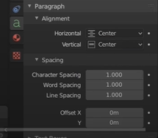

Step – 2:

Press TAB to change the text → write anything to your convenience and make changes in the geometry.
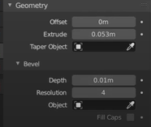

Step – 3:

Press the tilde key (~) and select top → Add → camera.

Step – 4:

Now for the path of the light (circular path) Add → Circle and then Add → Light → Point.
On light → Constraints (on the properties window) → Object Constraint → Follow Path → Bezier Curve..

Step – 5:

Press S to scale the circle and adjust the curves along the text.

Step – 6:

Now in the Animation Window select No. of frames. For this I have selected 120 frames.

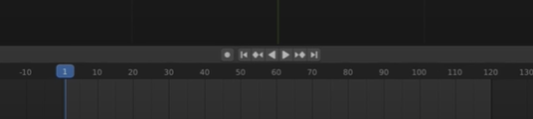

Step – 7:

Now at Frames 1 and 120 insert key frames from the properties window.

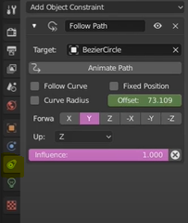

Step – 8:

Go to World settings → background → black, select text (remain in the same setting) → increase the metallic property.
Now go to the EVEE settings and turn on the BLOOM and also the screen space reflection.

Step – 9:

Choose point → Light (in the settings) → power/color (according to the requirement).
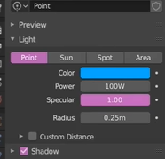

Step – 10:

Select the circle path, hit the TAB button, bring the path a little behind the text.

Step – 11:

Now to add the shading effect, Go to the Shading Window → Add →
- COLOR RAMP (color to the Roughness(principled BSDF))
- NOICE TEXTURE (Color to FAC(both the color ramps))
- MAPPING NODE (Vector to Vector(mapping node))
- TEXTURE COORDINATE (Object to vector(text. coordinate))
- BUMP NODE (Normal to Vector(principled BSDF))
- COLOR RAMP (Color to Height(bump node))
- DUPLICATE 1(color to FAC(mix shader)),2,3&4
- MATERIAL OUTPUT
- MIX SHADER (BSDF to shader / shader to surface(Material output))
- EMISSION (Emission to Shader(Mix shader))
Make the adjustments according to the rquirement.
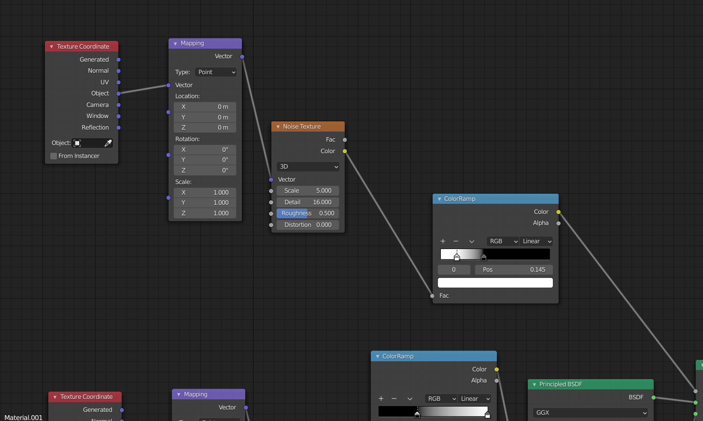
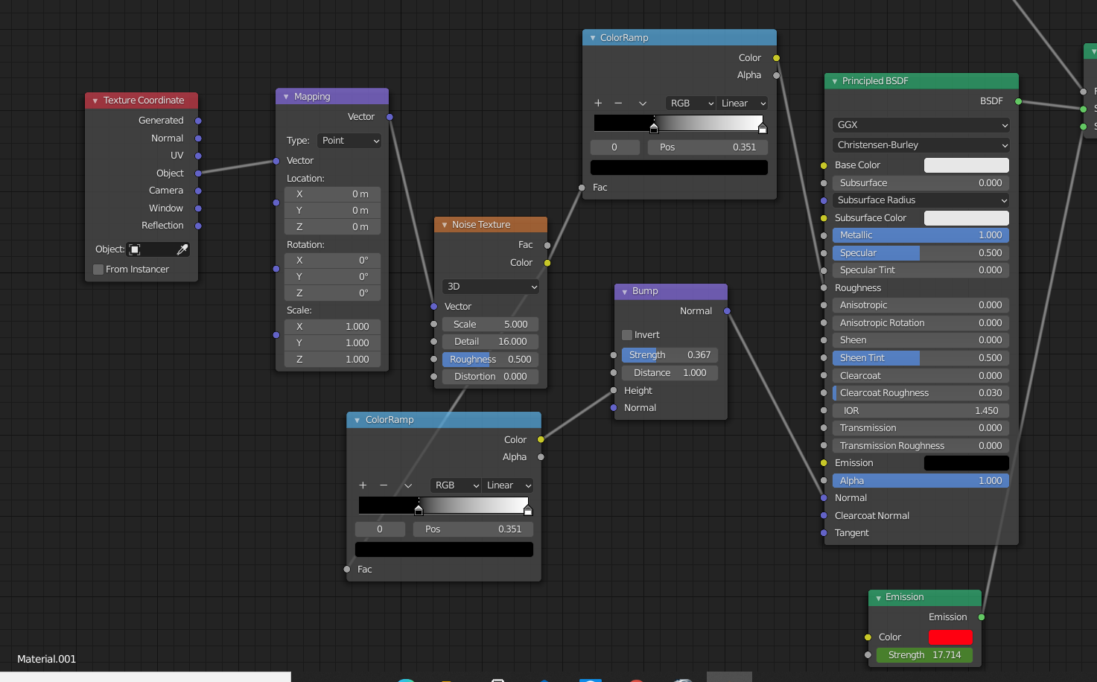
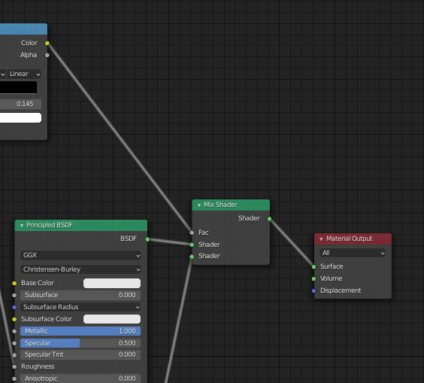

Step – 12:

Now Go to Timeline window → Frame 1 → Emission Stregth 0 → Add Keyframe → Frame 1 → Emission Stregth 0 → Add Keyframe

Step – 13:

Final Output:-
